**EC2 Basics Lab**

**Objective**: To understand the process of setting up and managing an Amazon EC2 instance.

**Steps:**

1. Click on button -> Launch instance

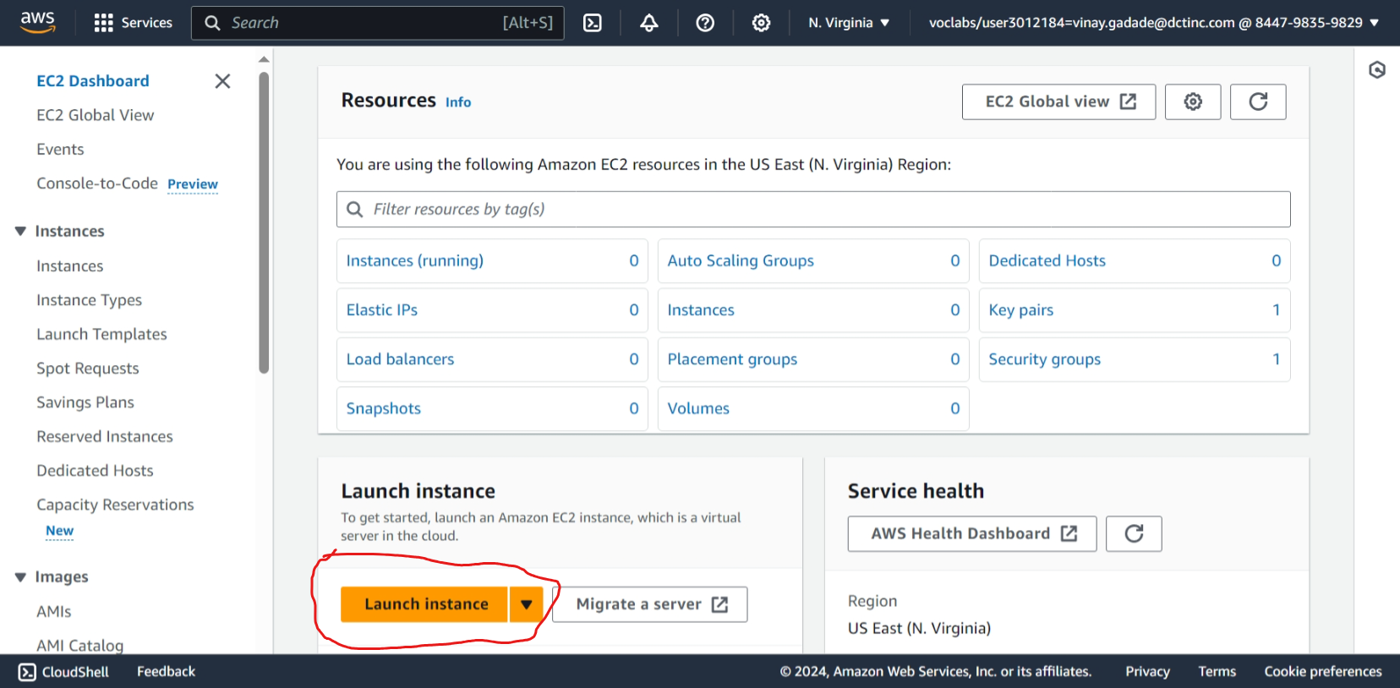

1. Create new key-pair

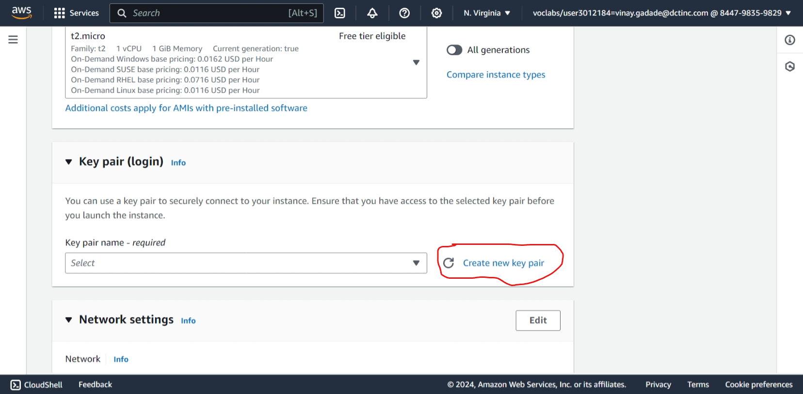

1. Create key pair with .pem for use for windowa 10 or above

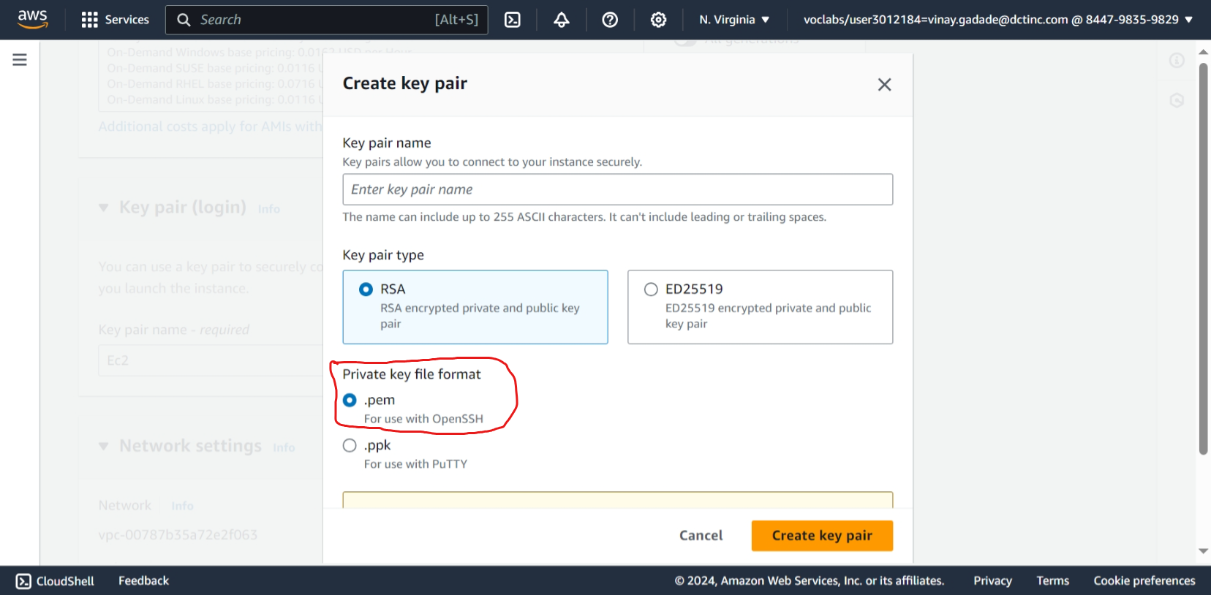

1. Set address in security group as anywhere for accessing site from any ip Address

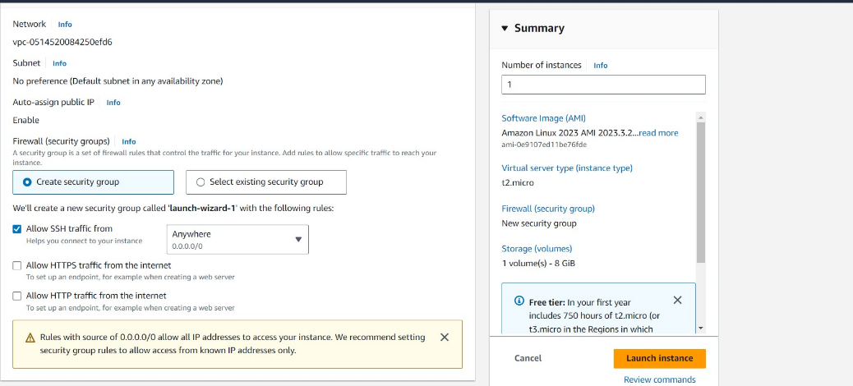

1. Launch instance

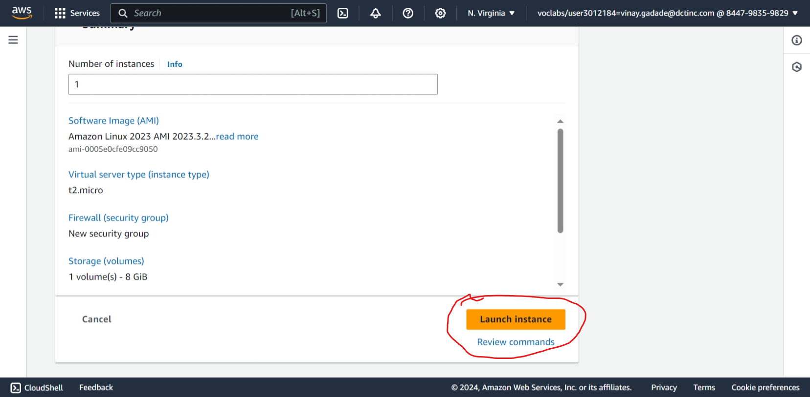

1. Select Elastic IPs

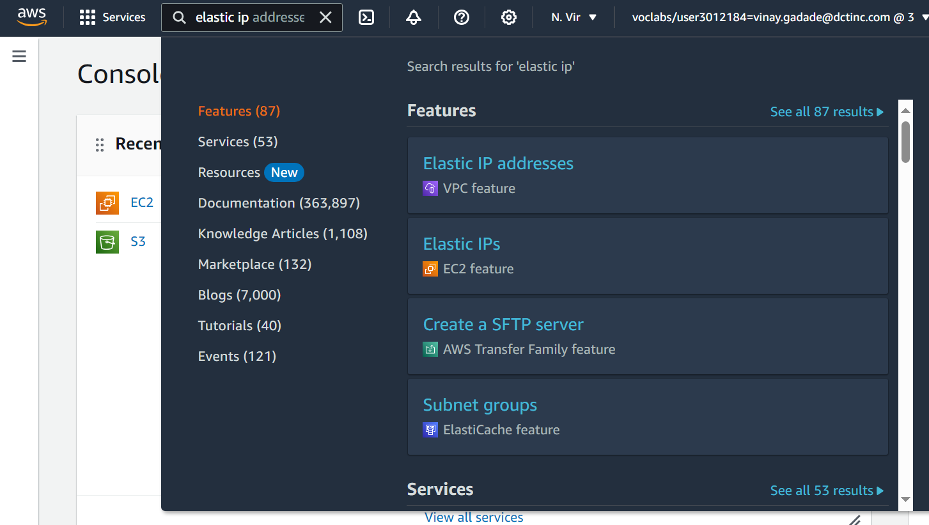

1. Select Allocate Elastic IP Address

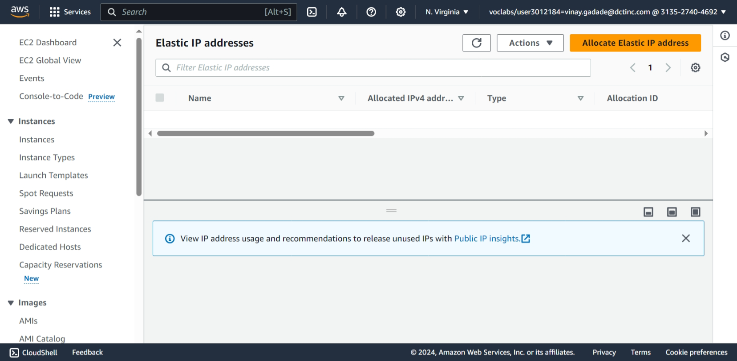

1. Scroll down and select Allocate

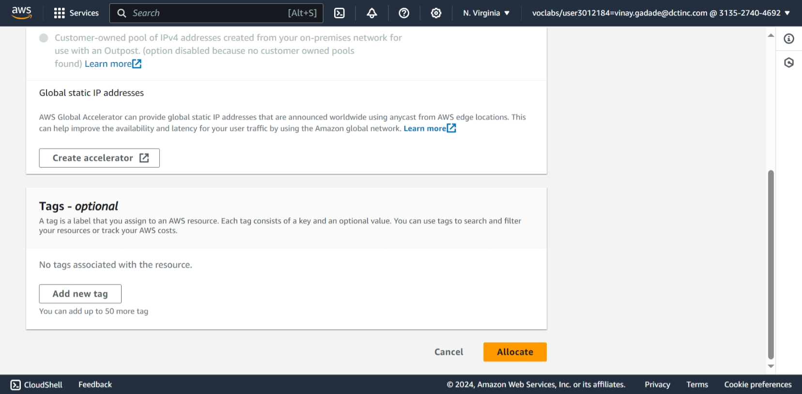

1. Click on Associate this Elastic IP Address

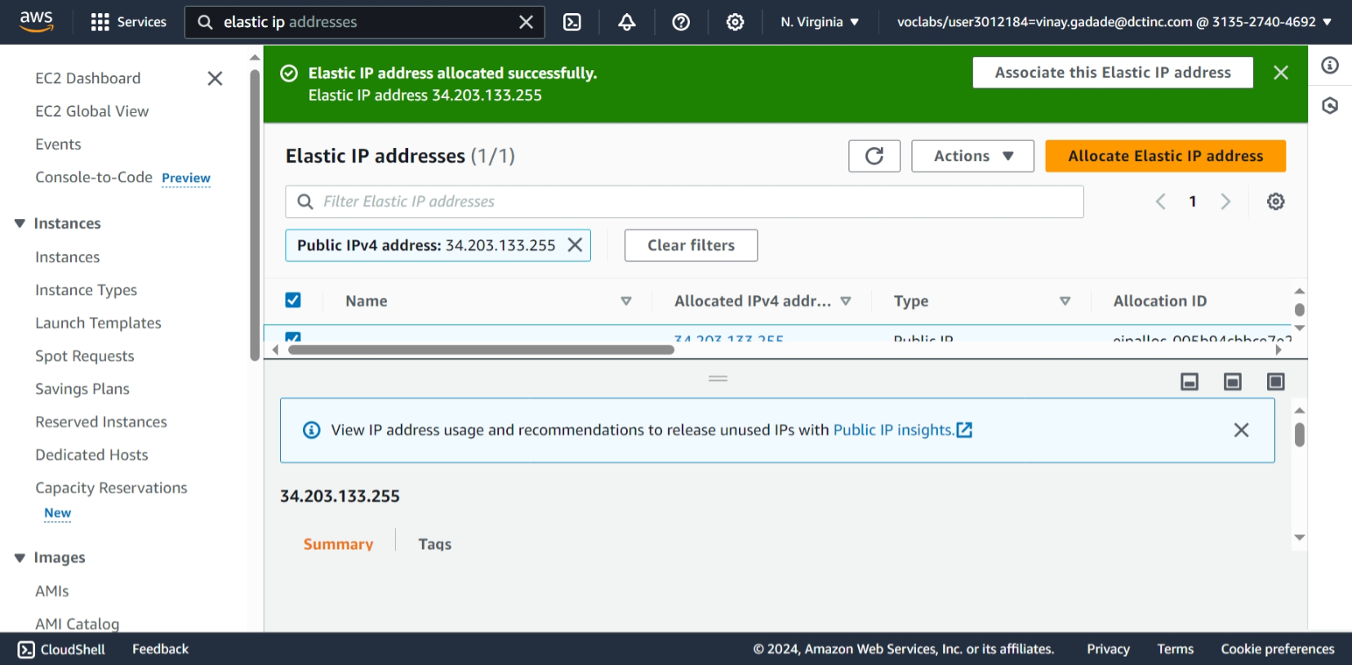

1. Click on Instances and Private Ip Address simultaneously and select Instances id and private Ip Address.

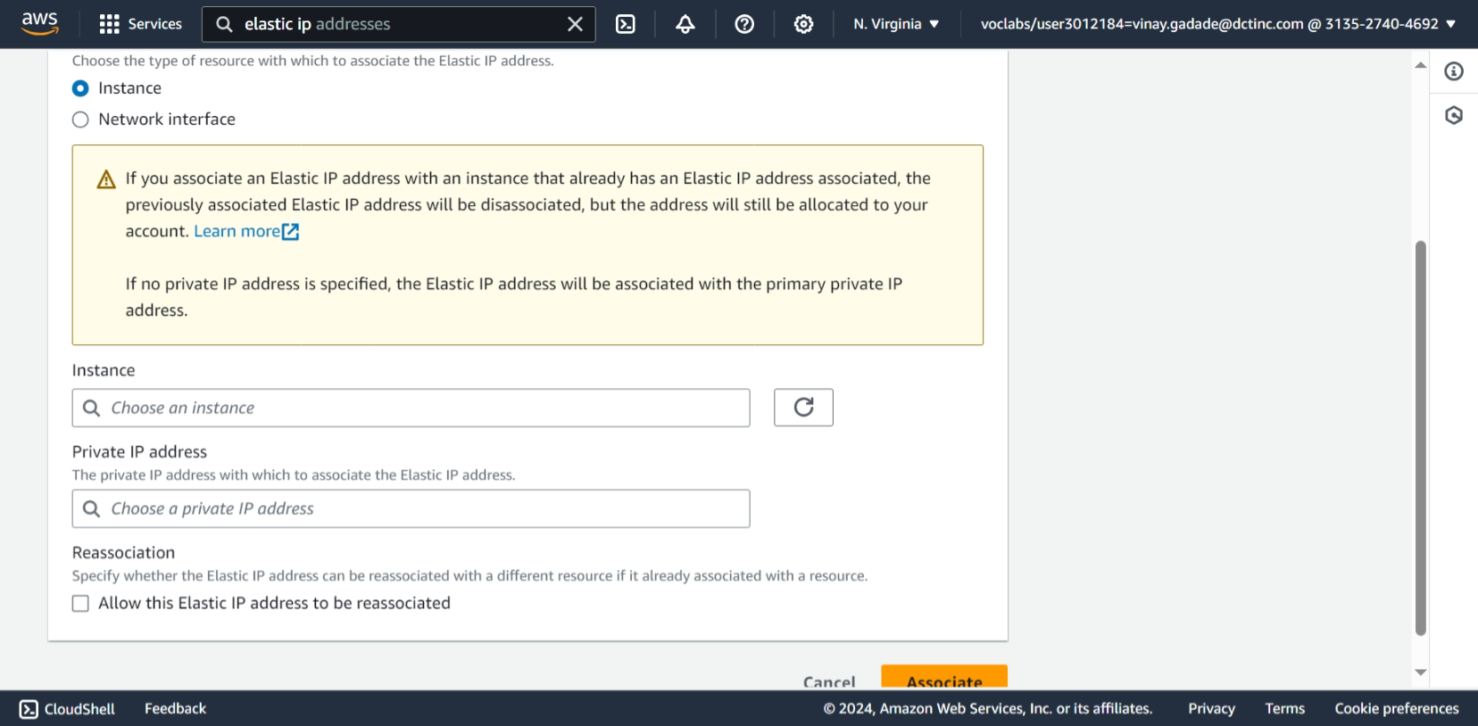

1. Click on Associate

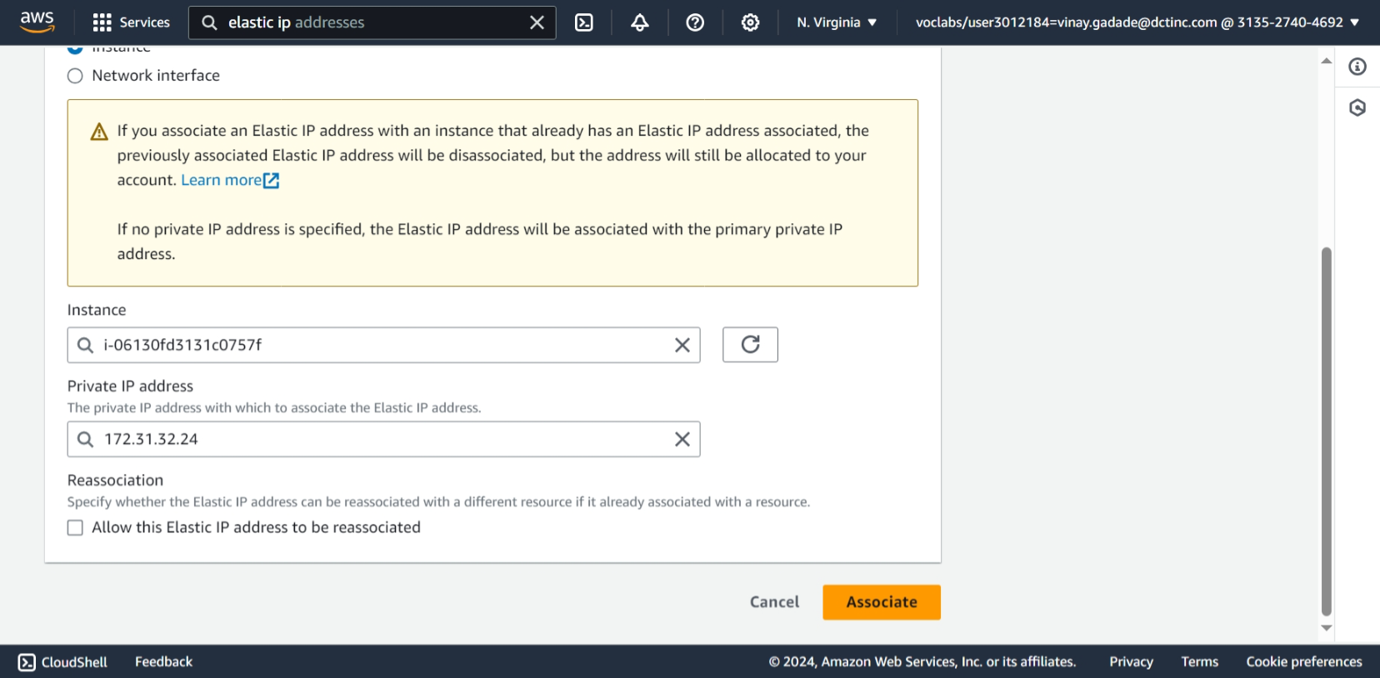

1. Elastic Ip Address get associated with our EC2 Instance

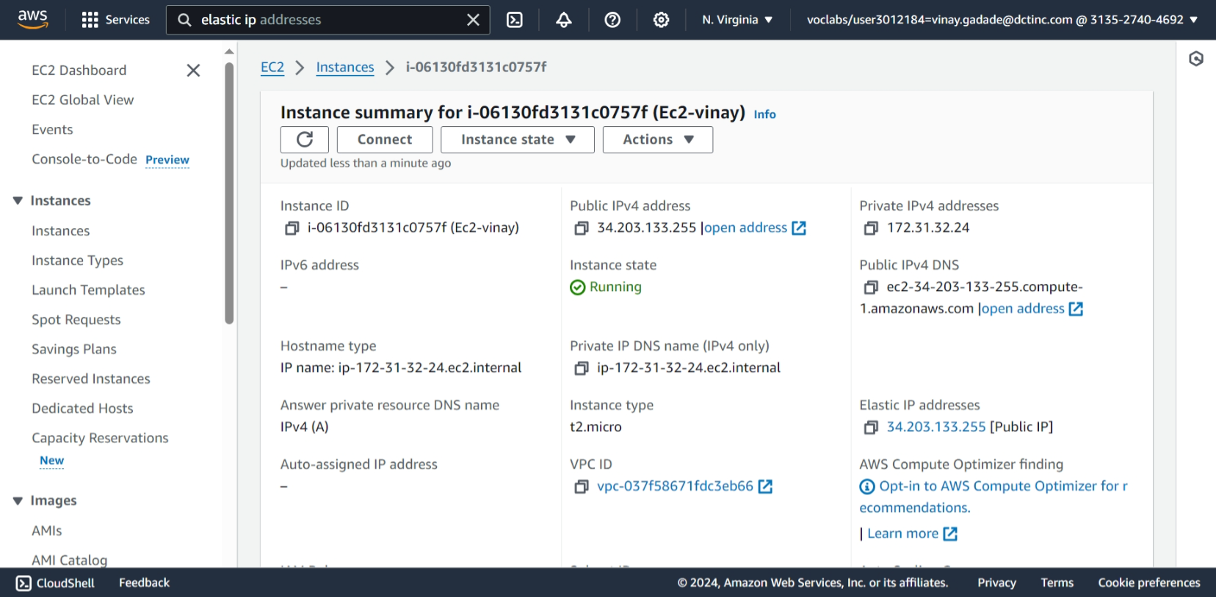

13)Instance is running, acsses using public ip .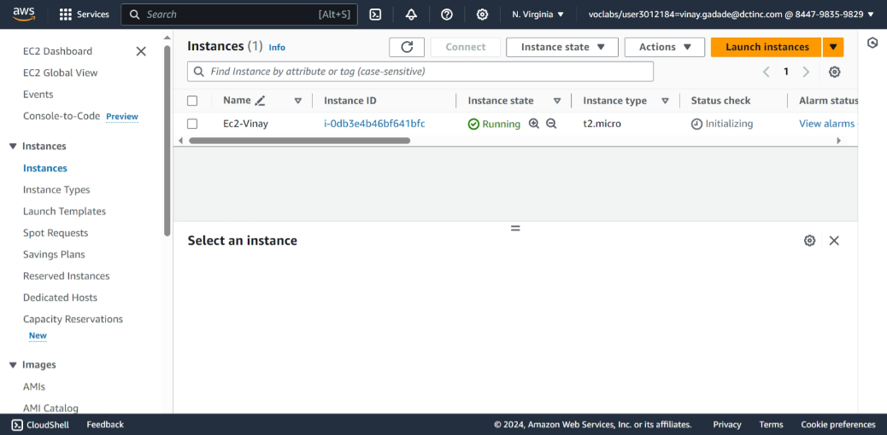

1. Click on connect and then open SSH client then copy Example command

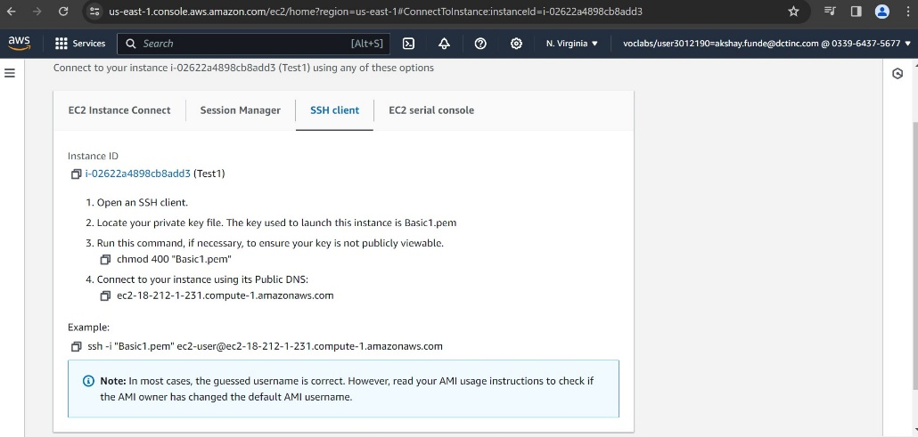

1. Open cmd in location of pem file and paste that command without any quotes and press enter then type yes .

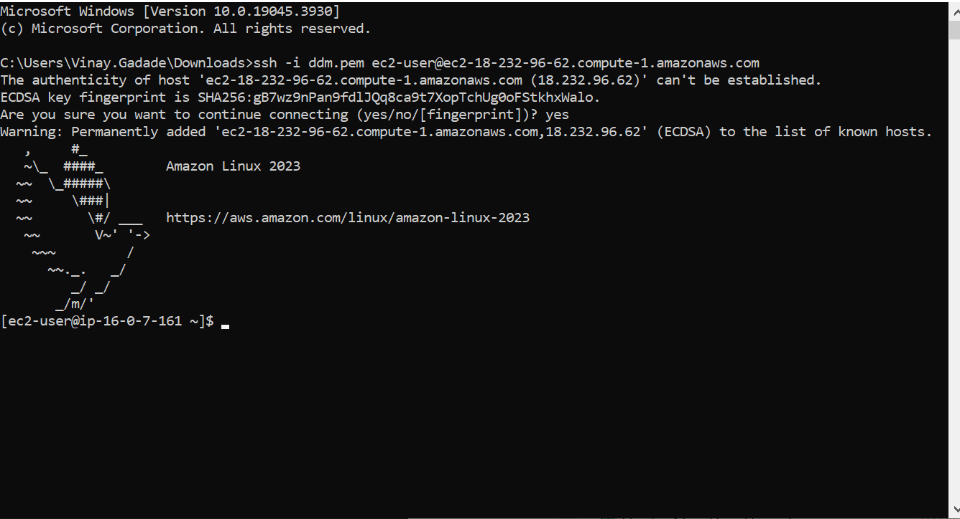

**S3**

**Storage Fundamentals Lab**

* **Objective**: To gain hands-on experience with Amazon S3 by performing basic storage operations

1. Click on create bucket

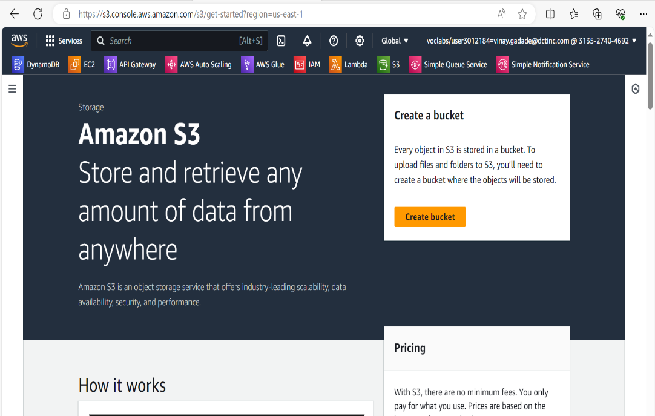

1. Create s3 bucket with unique name because it has universal naming in s3 bucket

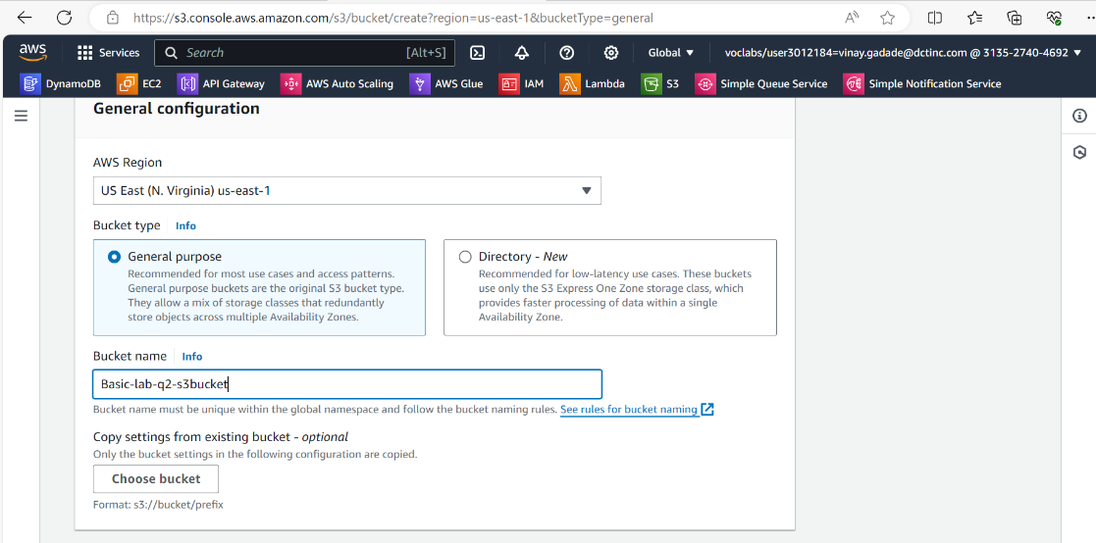

1. Click on ACLs Enbled for public acsses to uploaded objects

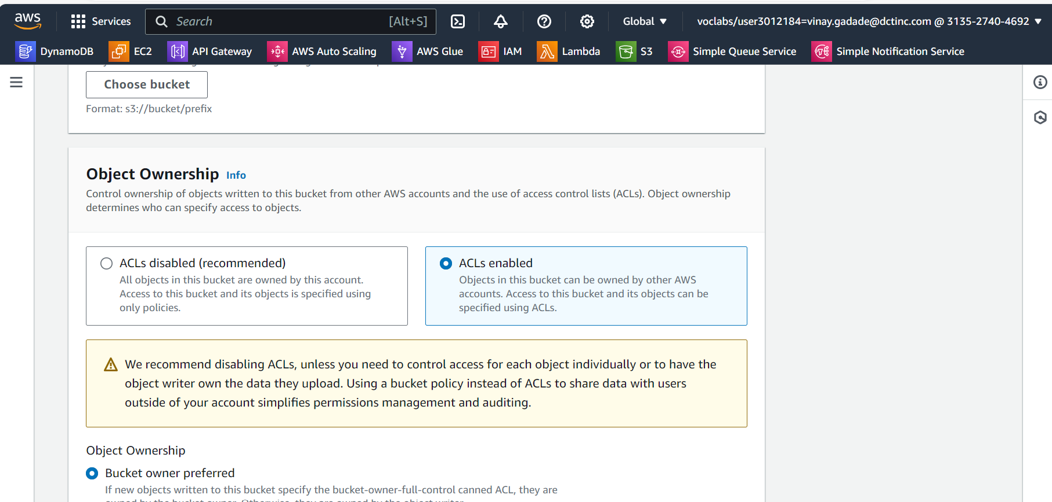

1. Untick Block all public access for getting public access to object.

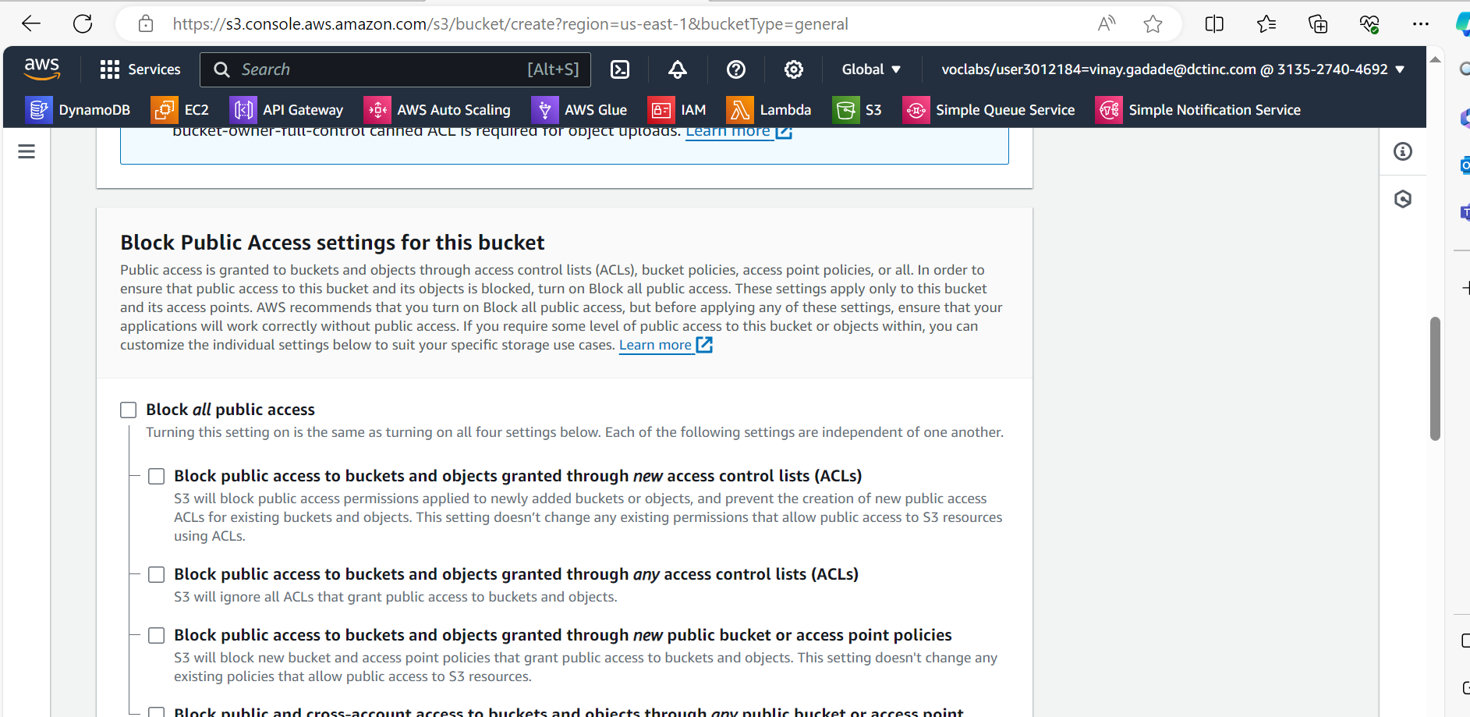

1. Click on create bucket.

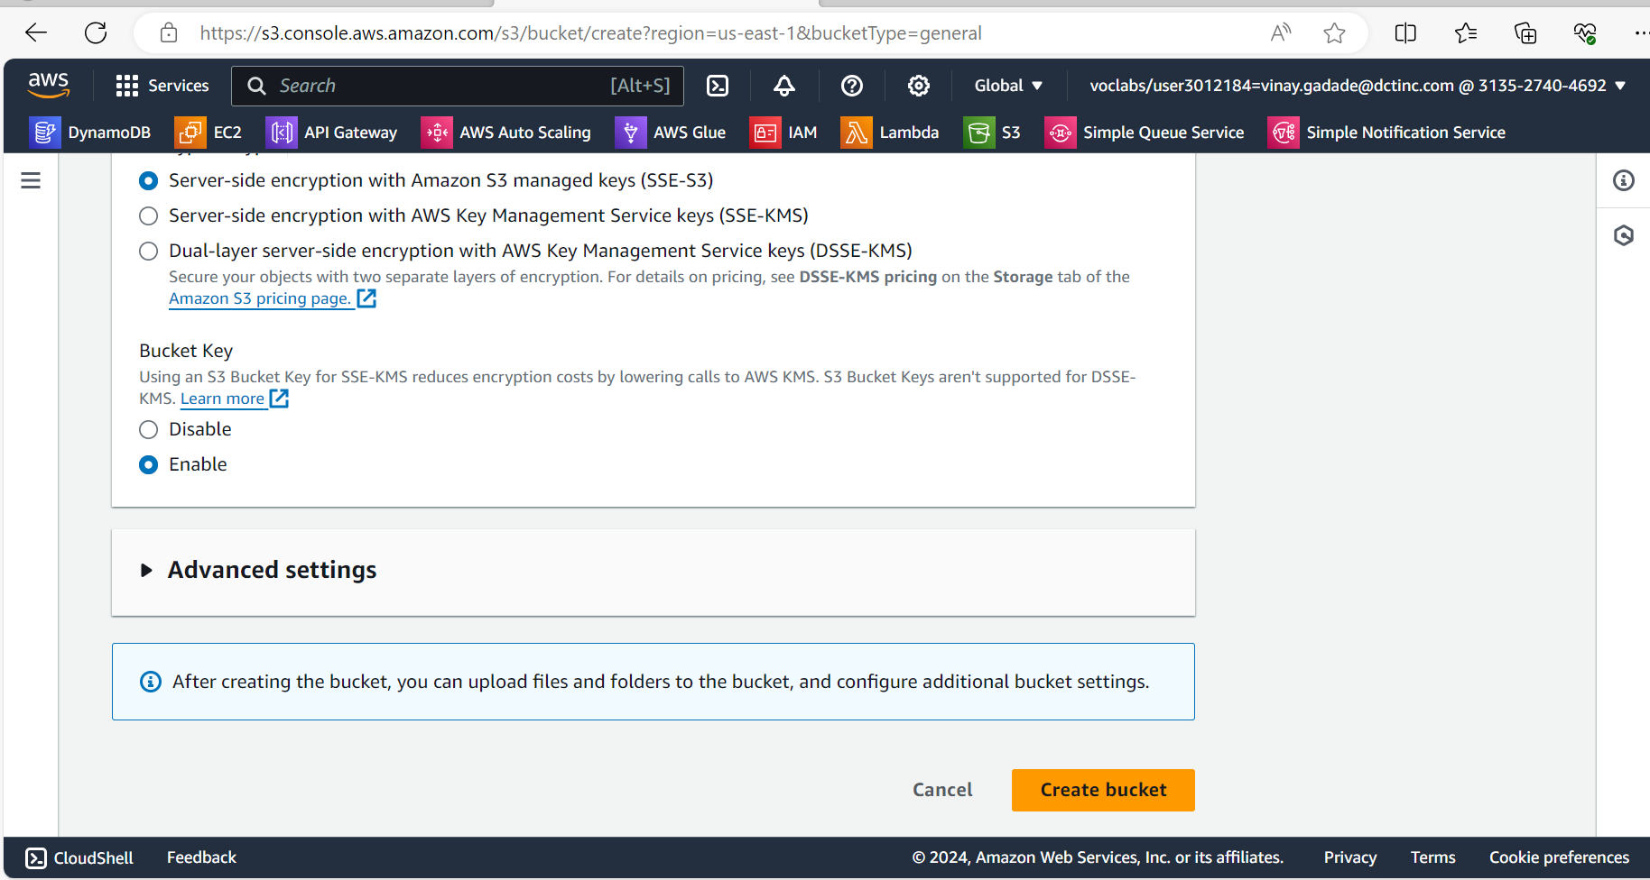

1. Bucket is now created , click on name of bucket .

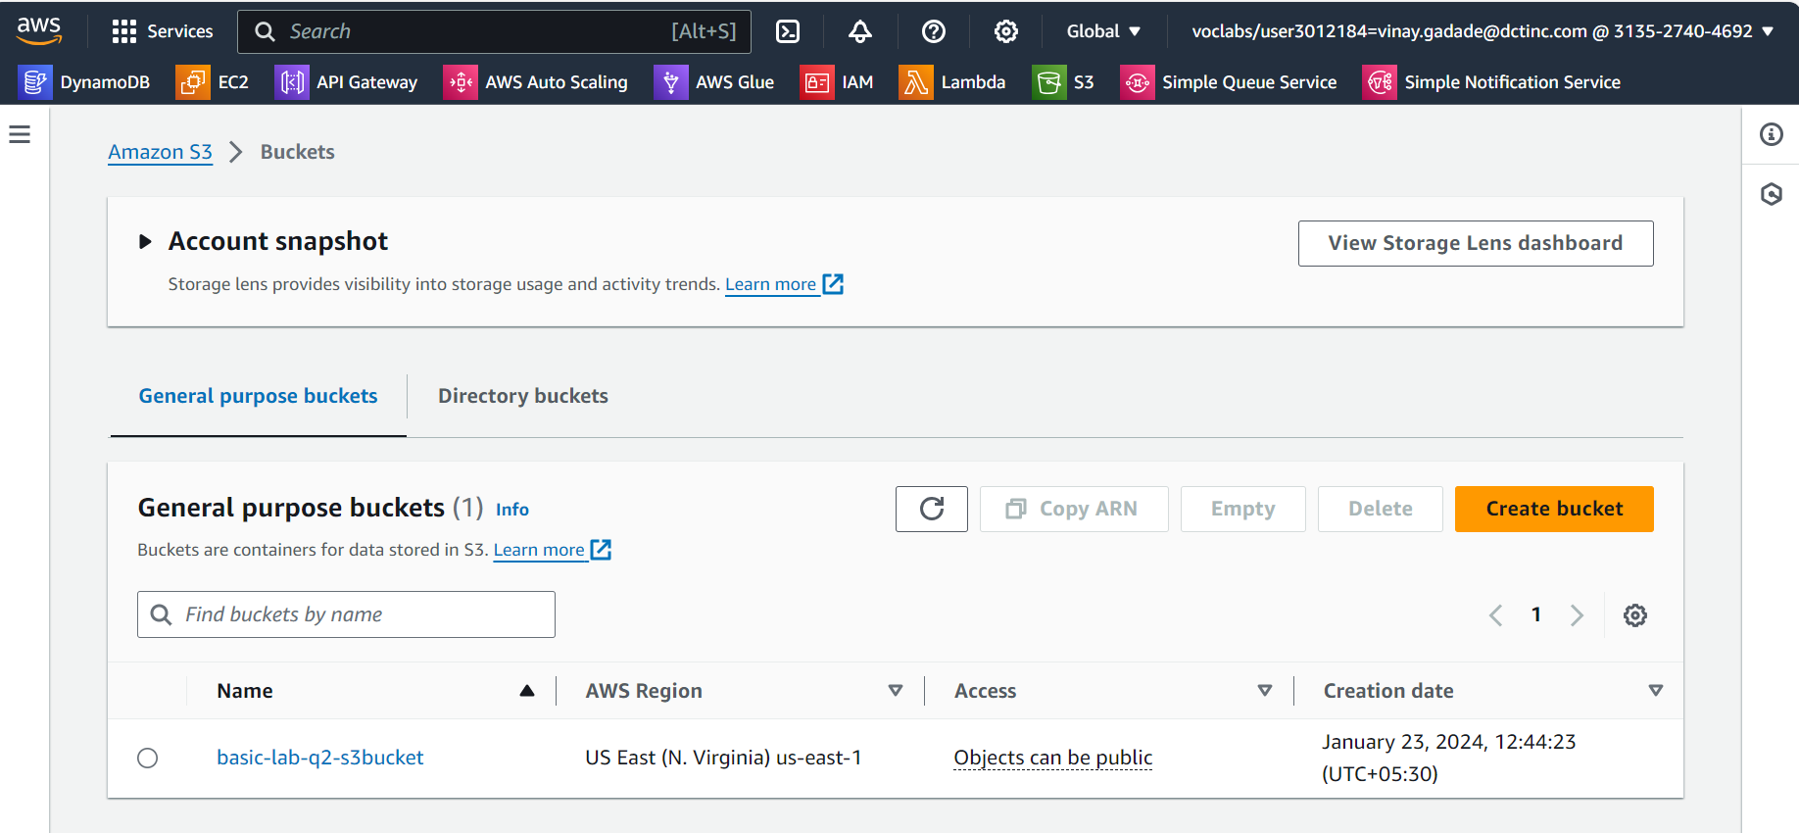

1. Now click on any Upload button to upload object in bucket.

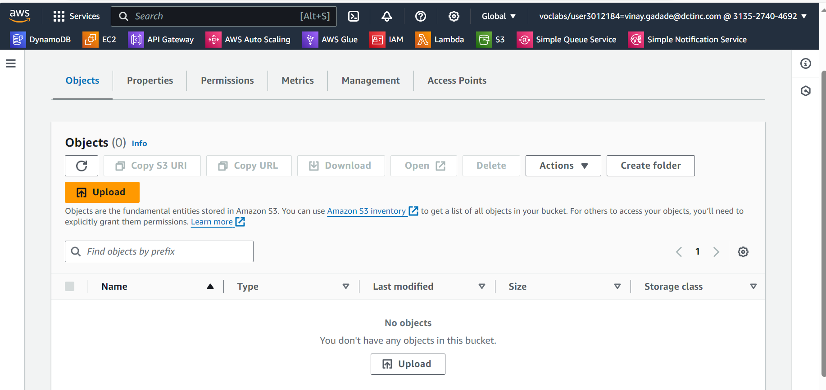

1. Click on Add file to add file (object) to bucket , you can drag drop the file in bucket or from location also you can add file.

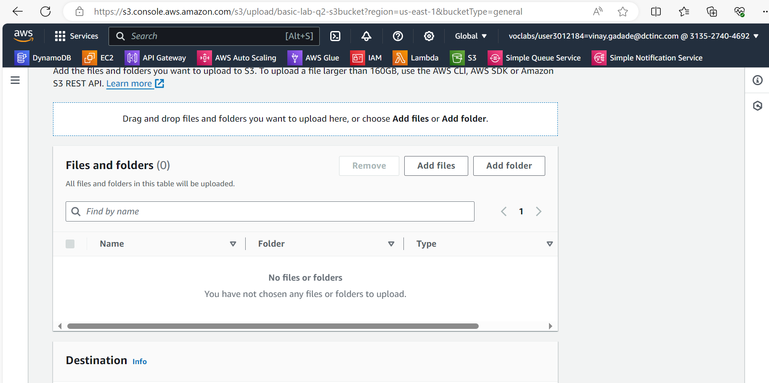

1. After adding file to bucket scroll down and click on upload button .

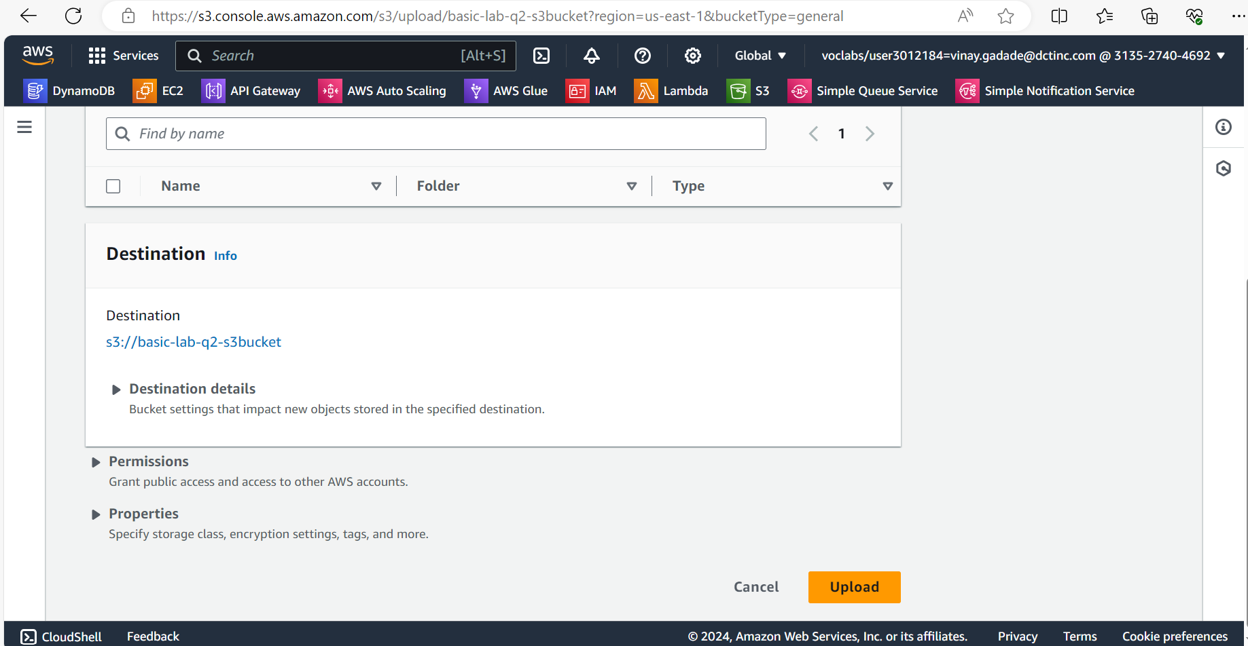

1. After upload click on object name and then click on object action for making object public click Make public using ACL

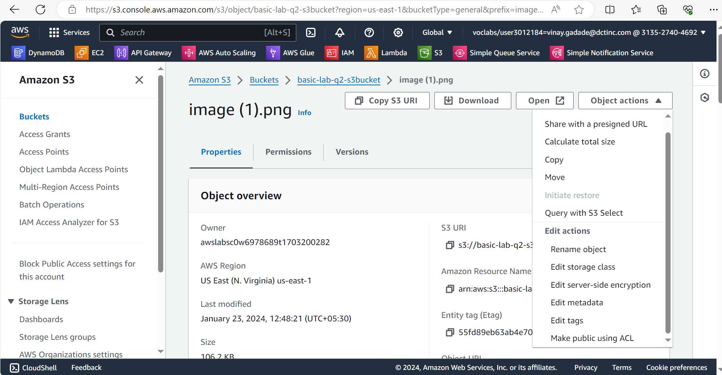

1. Then Click on make public button.

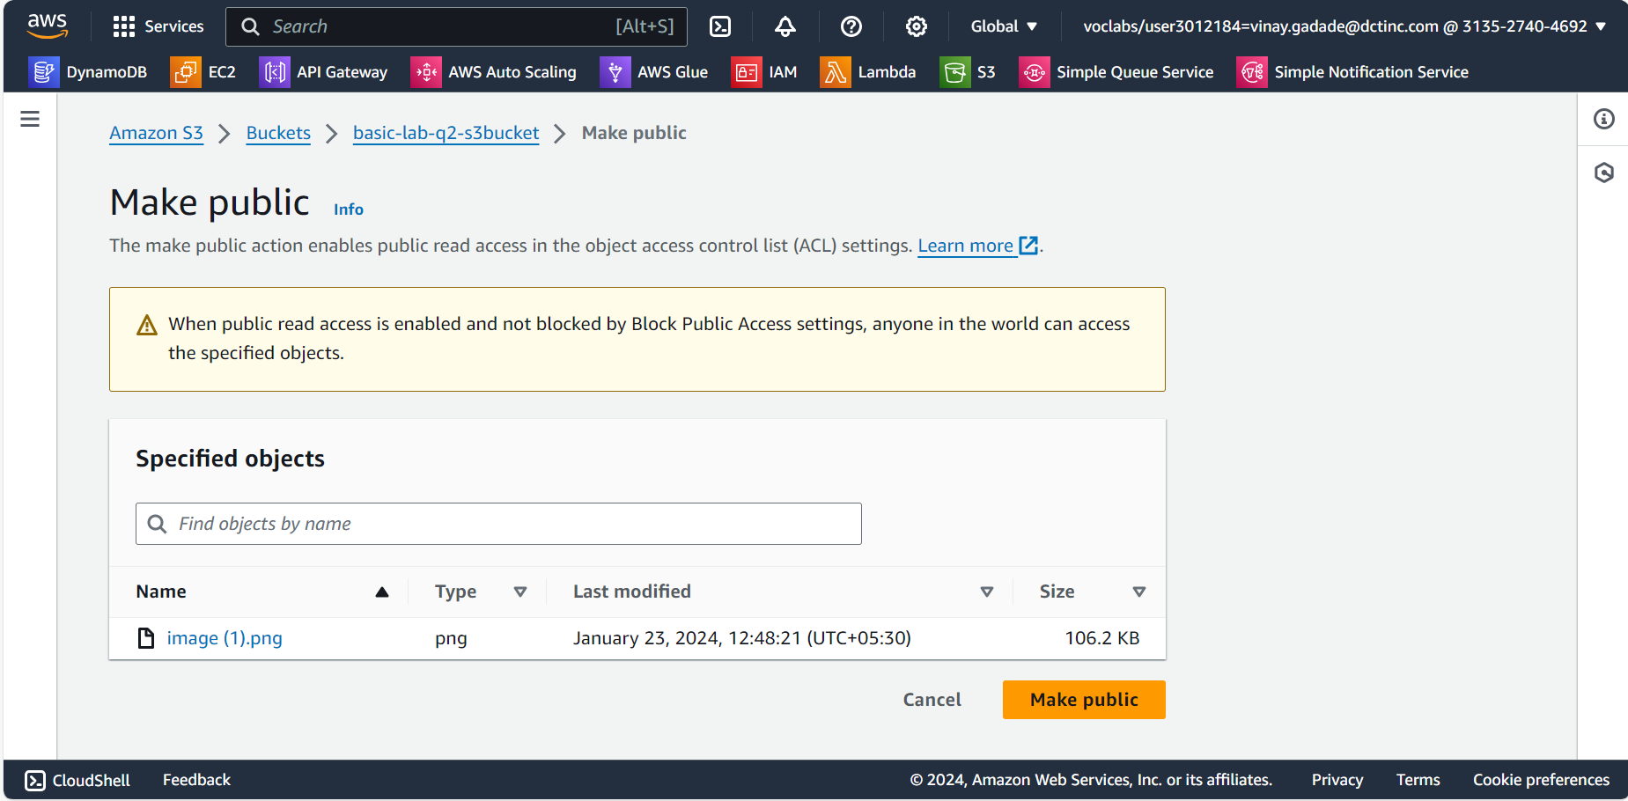

1. Click on Object URL for see object in public domain or browser.

. 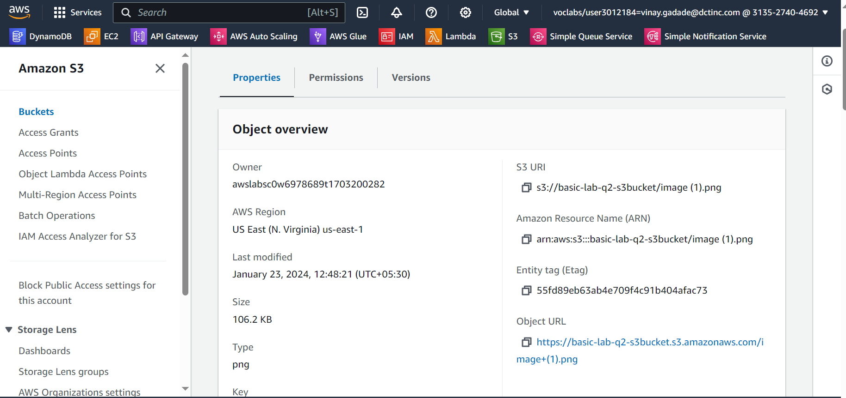

1. This is the object which uploaded in public domain.

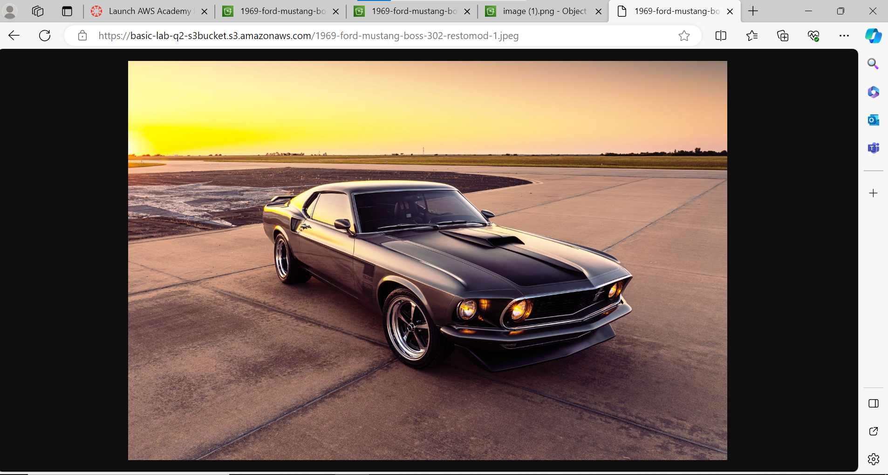

**VPC Configuration Lab**

**Objective**: To understand the fundamentals of AWS networking through the configuration of a Virtual Private Cloud (VPC).

* 1. **Navigate to VPC Dashboard**: From the AWS services menu, select "VPC" or search for it in the services search bar.
  2. Click on "Create VPC".

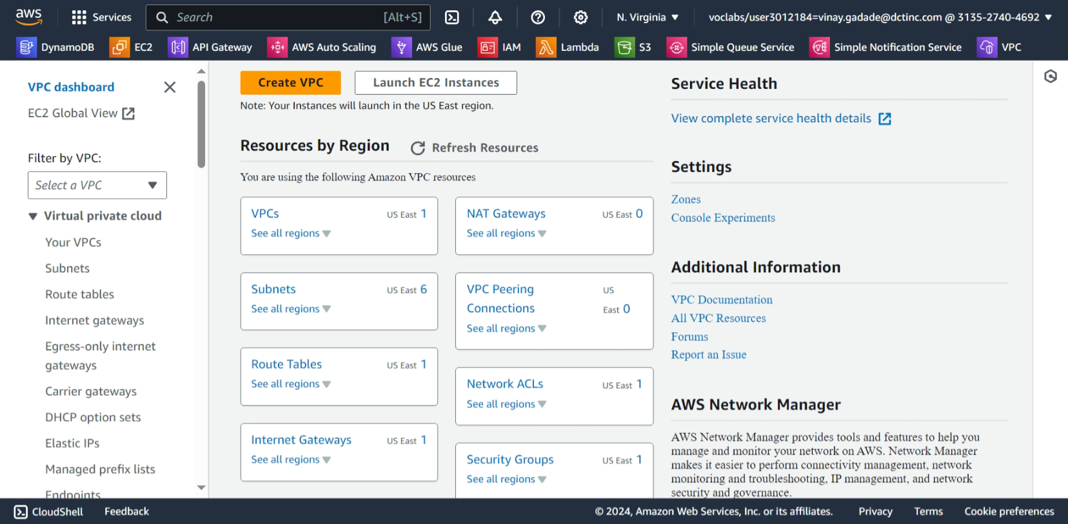

* 1. Then click on “vpc and more” for creating vpc with subnets and route tables .
  2. Then change name if you want or leave it default
  3. Set ipv4 cidr Block.
  4. Set AZs to 2 if one of the zone get stopped by any reasons it will switch to another one

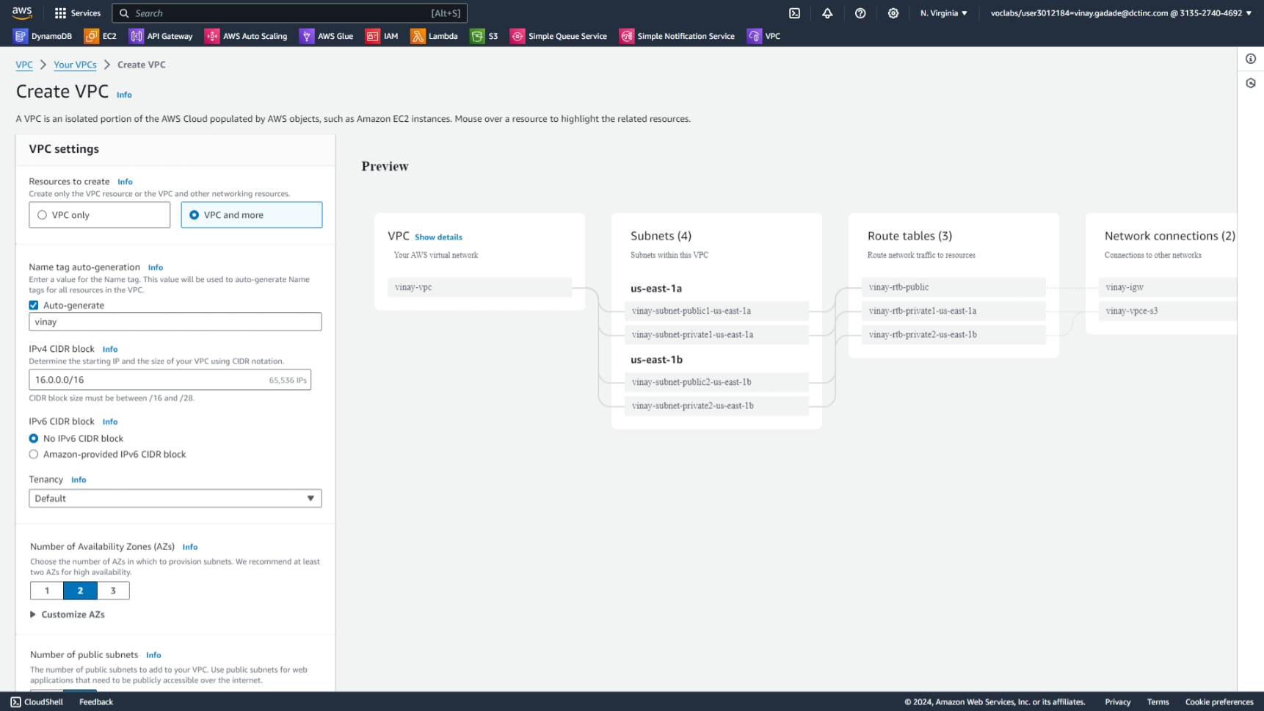

* 1. Set No.of subnet as your requirement public and private.
  2. As your requirement change CIDR block subnets.

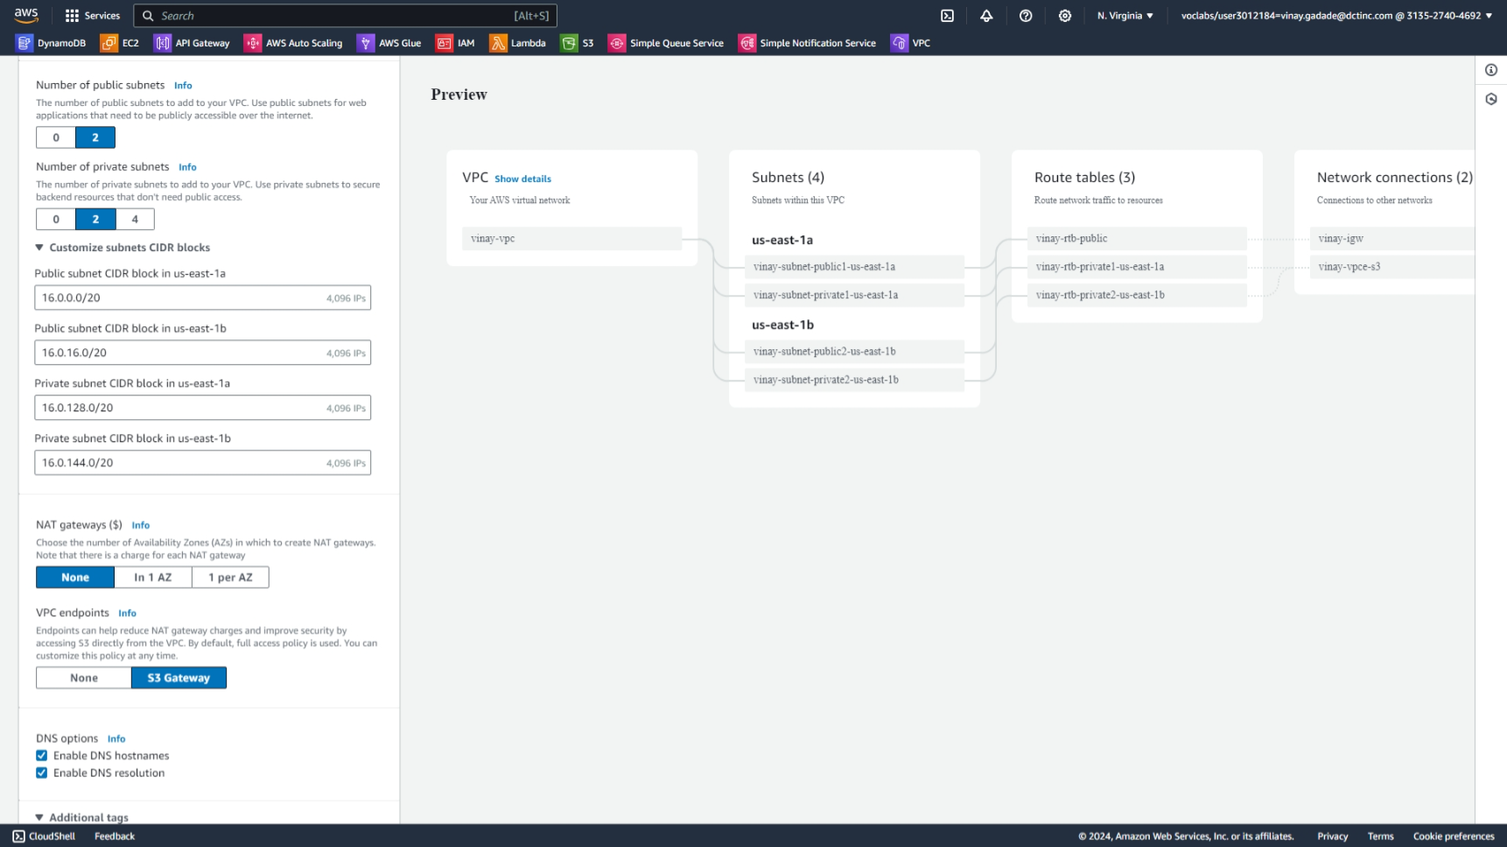

9)click on create vpc button .

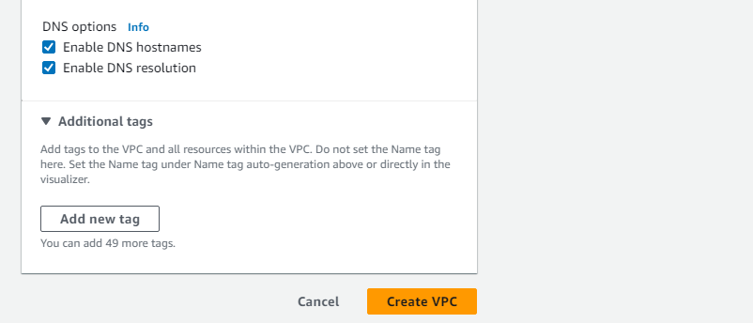

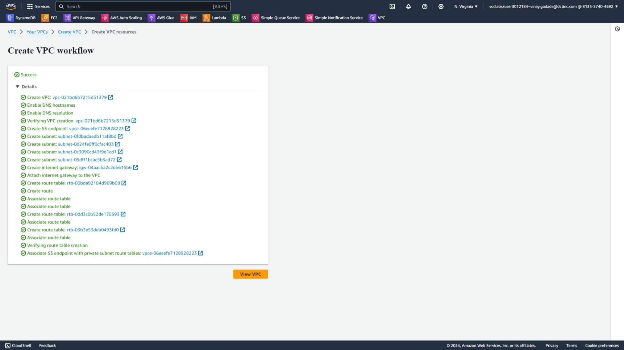

* 1. If we want to create another subnet,route tables or internet getways then on vpc dashboard on left side we have options using them we can easily create all extra necessary things.

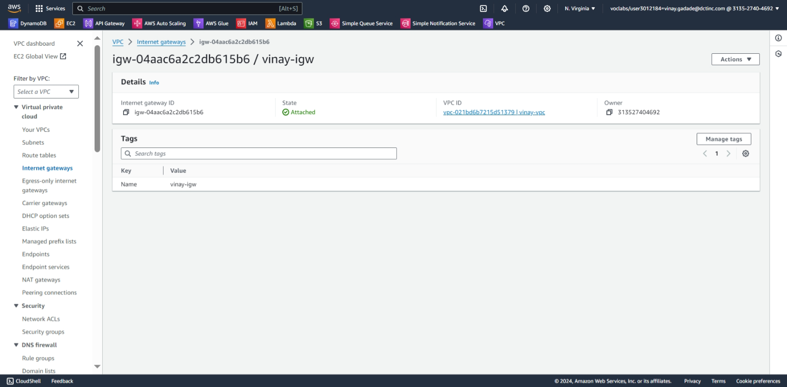

* 1. Then launch Ec2 instances

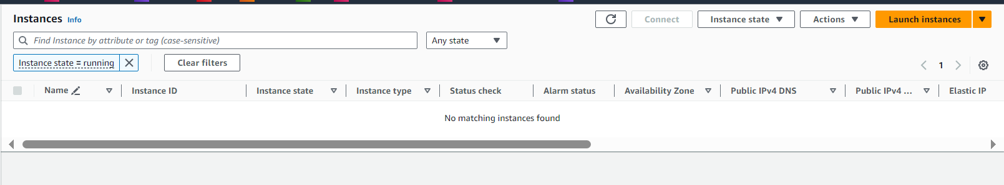

* 1. In network settings click on vpc and edit it to our created vpc
  2. Click on then click on subnet and set it to public subnet
  3. Click auto assign ip to public
  4. Then launch instance

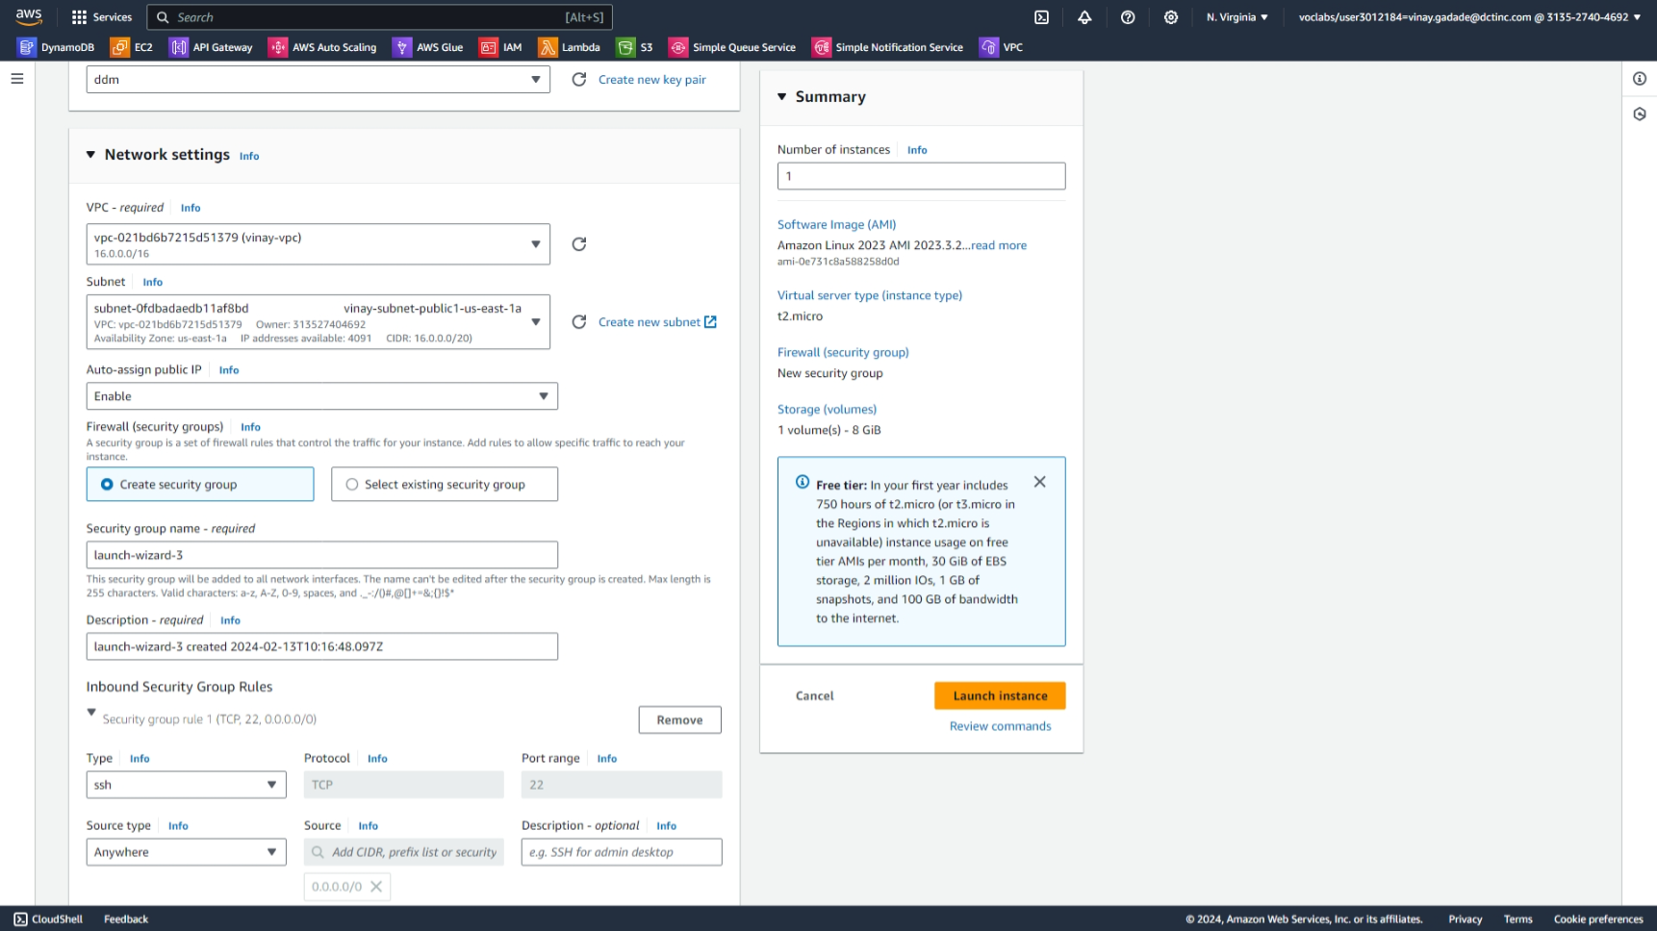



15)connected to consol using ssh and then we checked internet connectivity using public ip address 8.8.8.8 (ping 8.8.8.8) and it working

